$75 NATIONAL PTA VIRTUAL
CONVENTION GRANT
Application Deadline: February 28, 2023 Apply at https://form.jotform.com/221787416402152
Winners Announced: March 25, 2023 Quantity Offered: 20

The twenty National PTA Virtual Convention Grants pay the registration fee for PTA members to virtually attend the National PTA Convention. Attendees will be delegates representing Louisiana PTA. Experience all that National PTA does behind the scenes for the children of our country. It is an incredible opportunity and will be done from the comfort of your own home! Applications are submitted online.

Local Unit Name Local Unit Parish LUR#

Mailing Address City, Zip Current Membership # Grades at School

President’s Name Phone Email

Does the PTA have Active Affiliation status?
- Yes
- No

Requirements:
- All grant funds must be used to attend the 2023 National PTA Virtual Convention.
- Documentation of attendance must be emailed to submit@LouisianaPTA.org by July 1, 2023.

Questions:
- How many people want to attend 2023 National PTA Virtual Convention?
- What is/are the name(s) and current PTA positions (if applicable) of those wanting to attend 2023 National PTA Virtual Convention?
- What are the goals of the Local PTA Unit?
- How will the knowledge from 2023 National PTA Virtual Convention be shared with the parents, families, and community after the convention?

The above PTA fully understands that if it receives this grant, the money shall not be used for other programs or activities except for those listed on this application form. Documentation of LegCon attendance is due to submit@LouisianaPTA.org by July 1, 2023, unless an extension has been granted by the LAPTA President. The evaluation must contain all details pertaining to the use of the funds received under this grant including receipts of expenditures and any other supporting documentation. Failure to provide documentation requested as it pertains to this application may result in forfeiture of any or all grant funds and ineligibility of future grants.
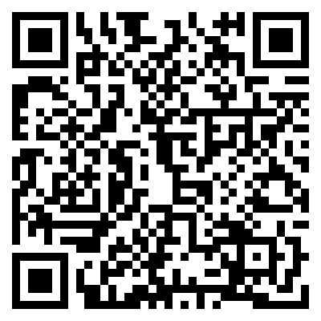
Applications must be submitted online at https://form.jotform.com/221787416402152 or scan the QR Code.

