Bylaws, Standing Rules, & Articles of Incorporation
2022 – 2023
Section 10

INDEX
Bylaws and Amendments: Updating and Approval 3
Bylaws and Amendments Approval Form 4
Instructions for Bylaws Template 5
Standing Rules 7
Articles of Incorporation 8

BYLAWS AND AMENDMENTS:

UPDATING AND APPROVAL
Bylaws are the fundamental governing rules of a PTA. They contain the basic rules related to conducting the unit’s business and governing its affairs. The Bylaws define the primary characteristics of the organization, prescribe how the association functions, and include all rules considered important to the rights and responsibilities of membership.
The Bylaws are a template created by LAPTA that includes required language which cannot be changed by the local PTA. The customizable areas are changeable by the local PTA to best meet their needs. Download the Bylaws template at LouisianaPTA.org/bylaws. Amendments to the customizable areas may occur at any time, and require approval by the General Membership at a meeting with thirty days (30) notice and then final approval by LAPTA.

LAPTA requires all local units to submit updated Bylaws every three years. All Bylaws have an “LAPTA Approval Date” on page one. The Board needs to know when the Bylaws expire and make a plan to update the Bylaws in a timely manner. To update or amend the Bylaws:

Form a Bylaws Committee of at least three members which must be approved by the General Membership. The committee shall include experienced and knowledgeable PTA members. The local unit President should have a copy of the current approved Bylaws or request a copy from LAPTA at Bylaws@LouisianaPTA.org.

Notify the General Membership in writing at least 30 days prior to the meeting as which the vote will occur to amend or update the Bylaws.

Obtain the official fill-in-the-blank LAPTA Bylaws template online at LouisianaPTA.org under the Run Your PTA menu or email Bylaws@LouisianaPTA.org, if Bylaws need updating.

Provide the Bylaws Committee with the old Bylaws for reference. Consider recommendations submitted by the Board of Directors and General Membership. For proposed amendments, all changes must meet the needs of the unit, have clear intent, and not conflict with the Louisiana and National PTA Bylaws. Amendments need to reference their article heading, section number, and line number(s) in the Bylaws.

Present the General Membership with the proposed Bylaws or amendments before the vote on the proposed Bylaws or amendments. Approval requires a two-thirds vote of the members present.

Complete the Bylaws and Amendments Approval Form found at the end of this section or at LouisianaPTA.org under Run Your PTA menu, Bylaws link. Attached the approved and complete Bylaws (not just the updated portion). Submit to Bylaws@LouisianaPTA.org. If an amendment does not fit in the space on the form, check the box for an attached addendum.

LAPTA reviews all Bylaws and amendments. If there are questions, LAPTA will contact the President. Once approved, they will be stamped “APPROVED,” signed, and dated. The stamped, signed, and dated copy is the official copy of the Bylaws. The Bylaws and amendments become effective once LAPTA emails back the final approval to the President’s email. Save the digital file in the PTA records and share with the Board.

BYLAWS AND AMENDMENTS
APPROVAL FORM

Local PTA units are required to review and submit their Bylaws to LAPTA every three years. The Bylaws Approval Form and the LAPTA Bylaws template is required. Visit LouisianaPTA.org/bylaws for details. Bylaws not in compliance will be returned to local unit. Email the completed Bylaws Approval Form and LAPTA Bylaws template or the amendments made in PDF format to Bylaws@LouisianaPTA.org. Please allow ample time for LAPTA to approve the Bylaws or amendments. Once completed, LAPTA will emailed the approved Bylaws or amendments to the President’s email.

Local Unit Name Local Unit Parish Local Unit LUR#

President’s Email President’s Phone

The Bylaws or Amendments were approved at the General Membership meeting held on .
DATE

Choose one.
The Local Unit PTA is: Existing PTA Reinstated PTA New PTA

Choose all that apply.
The Bylaws approved by the General Membership are attached.

List approved amendments below including the article heading, section number, and line number(s).

If more space is needed for amendments, check here for the attached addendum.

President’s Signature Secretary’s Signature

President’s Name Secretary’s Name

Email the completed Bylaws Approval Form and Bylaws template (if applicable) to Bylaws@LouisianaPTA.org in PDF format. Allow ample time for LAPTA to approve the Bylaws or amendments. Once completed, LAPTA will email the final approved document to the President’s email.

Contact Bylaws@LouisianaPTA.org with any questions.

INSTRUCTIONS FOR
BYLAWS TEMPLATE
The official Louisiana PTA fill-in-the-blank Bylaws simplify the amendment process and expedite approval. Articles or sections without bolded text are required and cannot be altered in any way; therefore, they must be included exactly as written. Changes can only be made to sections of the Bylaws that have “bolded” areas. Additional changes to these sections should be listed in an addendum.

Page 1: PTA Unit Information
Line 2: PTA Unit’s Name
Line 4: Local unit registration number (LUR#)
Line 5: Federal Employer Identification Number (EIN) If your unit is new or reaffiliating and does not have a LUR# or EIN but has applied for them, email the information to bylaws@LouisianaPTA.org upon receipt.
Line 7: School that your PTA/PTSA supports
Lines 9 -11: School address
Line 13: Parish that your PTA Unit is in

Page 2: Article I: Name
Line 35: PTA Unit name and city

Page 6: Article V: Membership and Dues
Line 214: Fill in the dues amount each member will submit to the local PTA/PTSA. If your unit offers a family, student, or corporate/business membership, include the dues for each member and the number of members allowed for each designation. For example, $8 for a single, $5/student, $15/couple (2 members), $50/corporate (5 memberships). Remember that your PTA must submit dues of $3.50 for each member in your unit to LAPTA.

Page 6: Article VI: Officers and Their Election
Line 228: Fill in the number of vice-president(s)
Line 229: Fill in the number of secretary(ies)
Line 231: List any additional officers in the addendum.
Line 234: Fill in the month or months your elections will be held which must be a month a General Membership Meeting is held.
Line 243: Fill in the date your elected officers will assume their positions. The PTA operational and fiscal years runs July 1 – June 30.
Line 244: Fill in the length of the elected officer’s terms.
Line 245: Fill in the maximum number of additional terms elected officers are allowed to serve.

Page 9: Article VIII: Executive Committee, Section 4B. Meetings
Line 362: Fill in the number of days’ notice that will be provided to the Executive Committee members in the event of a special meeting of the committee.

Page 10: Article IX: Board of Directors, Section 5B. Meetings
Line 409: Fill in the number of days’ notice that will be provided to Board of Director members in the event of a special meeting of the board.

Page 11: Article X: Committees, Section 5. Nominating Committee
Line 453: Designate the number of members for the Nominating Committee (no less than three members and an uneven number).
Line 458: Fill in the month or months the Nominating Committee reports at the General Membership meeting in which elections will be held.

Page 12: Article XI: General Membership Meetings
Line 473: Section 1. Meeting Dates. Fill in the months your unit will hold general membership meetings. Be sure to include the month/months your election is held.
Line 480. Section 3. Quorum. Fill in a quorum of at least twice the number of officers listed in Article VI: Officers and Their Elections, Section 3 and any additional officers listed by your unit in the addendum, plus one. This is to prevent the perception that the officers could conduct business of the association by themselves.
Line 482. Elections Meeting. Fill in the month or months your elections will be held. This must be a month or months a General Membership Meeting is held.

Page 13: Addendum. List any changes made to the Bylaws other than the information inserted in the blanks. Please include the page number plus article and section number when listing the changes. An example:
Page 12, Article XI, Section 4. Elections meeting. Current wording:
The annual elections meeting shall be held in the month of April.

The proposed change will be to:
The annual elections meeting shall be held in the month of May.

Questions? Send a note to bylaws@LouisianaPTA.org.

STANDING RULES
Local PTA Units should have their own set of standing rules. The following guidelines for local standing rules are suggestions and should be attached to your standing rules for ongoing reference and instruction. PTAs should adapt the wording to apply to them. Standing rules are the rules your PTA adopts to administer affairs under the provisions of your Bylaws. Standing rules must conform to and may not conflict with your Bylaws. Standing rules are generally not adopted when a PTA is newly organized but are developed and adopted as needs arise.
Standing rules are detailed guidelines that contain additional information on who does what within the PTA. They set forth the procedures adopted to direct your PTA and to accomplish specific PTA work. They provide continuity and serve as a guide to ensure the orderly transfer of duties from one administration to the next. They are a valuable training tool for the orientation of new board members. They may contain any traditions or specific information that pertains to your PTA.

Standing rules are more flexible than Bylaws. They do not contain parliamentary procedure but are adopted and amended. Standing rules are kept with your Bylaws in your officers’ procedure books and passed on to incoming officers. All Board members and committee chairs should have a copy of your standing rules. Your bylaws and standing rules need to be studied by your incoming officers as soon as they are elected and reviewed frequently for understanding and training and to ensure they are still accurate and applicable. Your secretary shall have a copy of your standing rules available at all PTA meetings.

Each set of standing rules is unique. No two are alike because no two PTAs are alike. Your standing rules may be organized in any way you desire, such as in articles and sections as in your bylaws, in numerical order as they are adopted, in topic and sub-topic groups, etc. Developing standing rules is not difficult. They may be adopted individually in a General Membership meeting as the need arises.

To adopt a set of standing rules, appoint a committee of at least three experienced, knowledgeable members of your PTA to prepare a set of standing rules. Using your bylaws as a starting point, the committee should consider each provision and then formulate instructions for applying it. The minutes of Board and General Membership meetings and the experience of committee members are additional resources. After the committee has prepared the standing rules, they are presented to your Board for review and then to your General Membership for approval by a majority vote.

Standing rules may contain as much information and detail as you want to include for the functioning of your PTA. The more details included the easier the job will be for future board members. Your standing rules should include any specific, detailed duties and responsibilities of your individual officers and commissioners, your Executive Committee, your Board, and your committee chairs. Details and descriptions that would be helpful include any consistent person, date, location, time, event, activity, assignment, tradition, and process that occurs traditionally during your PTA year.

Detailed information about the following additional topics and more could be included in your standing rules:

- Titles and specific duties of the vice presidents
- Orientation of new Board Members
- Procedure books
- Meetings
- Details for all standing and special committees, which could include finance, membership, public relations, newsletter, volunteers, programs, legislation, Reflections, Financial Resources, teacher appreciation, hospitality, etc.
- Committee duties, who serves on them, and how committee members are determined
- Needs assessment
- Student involvement
- Fiscal policies and procedures, including location of bank and updating signature cards and debit cards at the bank
- Nominating Committee instructions
- Installation of new officers
- Information and requirements for special recognitions and awards
- Equipment your PTA owns and where it is located
- LAPTA meetings and who attends

ARTICLES OF INCORPORATION
Louisiana law requires that all non-profits register with the Louisiana Secretary of State’s office. There is a $75 initial fee to file Articles of Incorporation with the Louisiana Secretary of State at geauxbiz.com.

The PTA must file the Annual Report yearly updating its officers. Visit the Louisiana Secretary of State at geauxbiz.com to renew, set up annual email reminders, update the officers, and pay a $15 renewal fee. The Articles of Incorporation shall be kept permanently on file and is part of the annual Active Affiliation Report that is submitted to LAPTA.

After logging into geauxbiz.com under “Quick Links,” select “File Annual Report.” Or click “Get Started” button. Select “File an amendment, such as an annual report, with the Louisiana Secretary of State.” Follow the steps to update officer data.

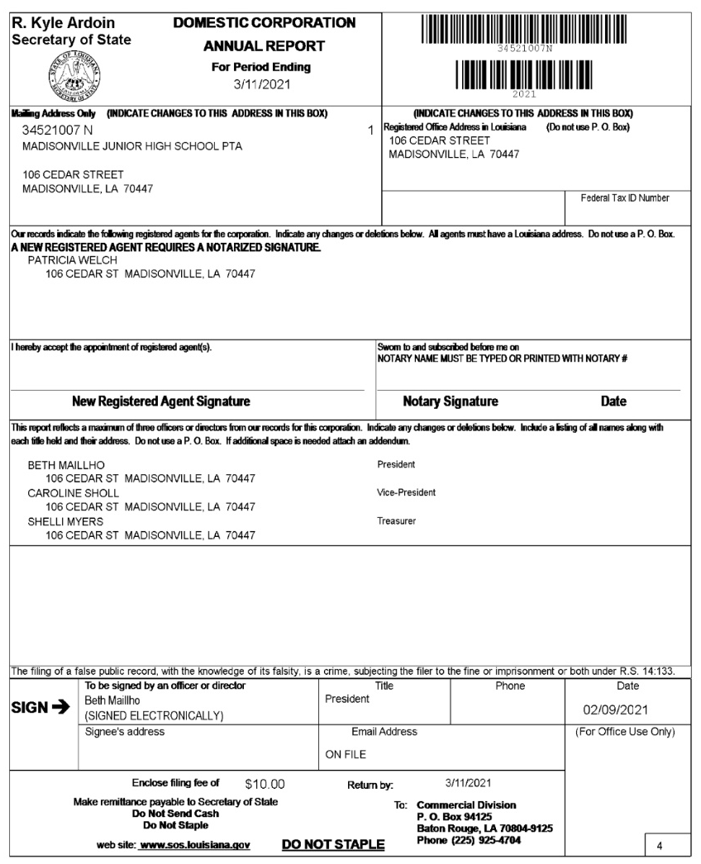
SAMPLE

