SAFETY POSTER CONTEST
FIRE PREVENTION WEEK
100TH ANNIVERSARY

National Celebration Week: October 9-15, 2022 Deadline to submit to LAPTA: October 18, 2022
Quantity Offered: 9 (Three/category) LAPTA Winners Announced: October 21, 2022
Submit Entries: https://form.jotform.com/221746113272146

As Louisiana PTA observes its Centennial Celebration, the Fire Prevention Week Program and Sparky the Fire Dog are also 100 years old! Fire Prevention Week is October 9-16, 2022. Check out nfpa.org/FPW for fire safety messages, activities, materials, games and apps, lesson plans, safety tip sheet, and more. Students can draw a Fire Prevention Safety Poster on regular 8½ X 11 white paper. Local PTA Units can pick three winners per Grade Category: Primary (Pre-K - Grade 2), Intermediate (Grades 3-6) and Special Artist Category (students of all ages with an ADA Section 504). Deadline to submit posters to LAPTA is October 18, 2022. LAPTA winners will be announced October 21, 2022.

There are several ways this can be organized. The PTA could choose to have the teachers do the contest in their classrooms, an art teacher could organize it, or it could be done at home by the students. Provide the copy paper for students, or they could even draw on the back of the flyer. Perhaps the local fire department could make a presentation to the students.

How to Submit Local PTA Winners to LAPTA
- The Local PTA Unit picks three winners per Grade Category to submit to LAPTA for consideration. Ensure that all winners have signed a Media Release Form with the school. Take a picture of the winning posters in good lighting from directly above the picture.
- Go to https://form.jotform.com/221746113272146 or scan the QR Code. Complete the form and upload the image by October 18, 2022. Information you will need is PTA name, Grade Category, student name, grade, and parent contact information. Repeat for each winner from your school.

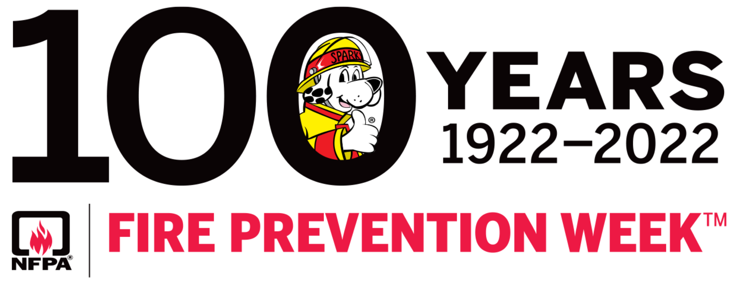

SAMPLE SAFETY POSTER CONTEST FLYER
FIRE PREVENTION WEEK
100TH ANNIVERSARY
DEADLINE: Friday, October 14, 2022

The National Fire Prevention Week Program, Sparky the Fire Dog, and Louisiana PTA are 100 years old! In observance of Fire Prevention Week, which is from October 9-16, 2022, students can draw and color a Fire Safety Poster on regular 8½ X 11 white paper. Students can use the back side of this flyer. What are some ways you can be safe when you are around fire?

Check out nfpa.org/FPW for fire safety messages, activities, materials, games and apps, lesson plans, safety tip sheet, and more.

There will be three Awards of Merit winners for each grade and three Awards of Excellence winners per Grade Category (adjust as needed) that will move on to the Louisiana PTA Safety Poster Contest. The Grade Categories are Primary (Pre-K - Grade 2), Intermediate (Grades 3-6) and Special Artist Category (students of all ages with an ADA Section 504).

Deadline to submit Safety Posters to the PTA is Friday, October 14, 2022.
Winners will be announced Wednesday, October 19, 2022.
Louisiana PTA will announce its winners on Friday, October 21, 2022.

Include how the contest will be organized. The PTA could choose to have the teachers do the contest in their classrooms, an art teacher could organize it, or it could be done at home by the students. Provide ample notice. Provide the copy paper for students, or they could even draw on the back of the flyer. Adjust your deadlines appropriately to be able to submit to LAPTA by October 18, 2022.

