ARTICLES OF

INCORPORATION
Louisiana law requires that all non-profits register with the Louisiana Secretary of State’s office. There is a $75 initial fee to file Articles of Incorporation with the Louisiana Secretary of State at geauxbiz.com.

The PTA must file the Annual Report yearly updating its officers. Visit the Louisiana Secretary of State at geauxbiz.com to renew, set up annual email reminders, update the officers, and pay a $15 renewal fee. The Articles of Incorporation shall be kept permanently on file and is part of the annual Active Affiliation Report that is submitted to LAPTA.

After logging into geauxbiz.com under “Quick Links,” select “File Annual Report.” Or click “Get Started” button. Select “File an amendment, such as an annual report, with the Louisiana Secretary of State.” Follow the steps to update officer data. Banks usually reference the Articles of Incorporation when they update signers; therefore, update this information before going to the bank to update signers.

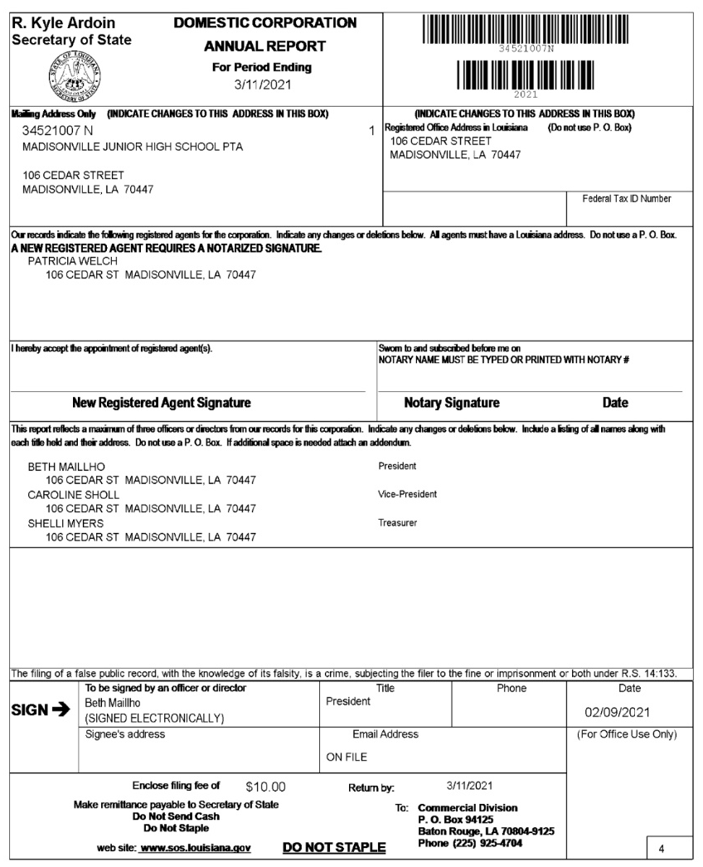
SAMPLE

