NSF SAMPLE LETTER
Returned Check Due to Non-Sufficient Funds
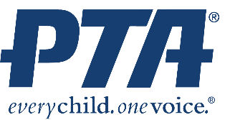
Current Date

Name of Check Writer
Address of Check Writer
City/Zip

RE: Check returned for not sufficient funds Check # 456
Check Issued Date
Tickets for the Fall Festival

Dear Check Writer,

The ABC PTA received notice on October 12, 2022, that the check written for Fall Festival tickets totaling $55.00 was returned to us due to insufficient funds in your account. Over the past thirty days, we have been in contact with you and the bank in an attempt to collect the amount owed for the tickets. A detailed log of contacts and actions is attached.

Immediate cash payment of $90.00 is required at this time. This includes the original amount of the check and three returned check fees from your bank. Please see totals below.

Check #456 $55.00
Bank return fee $15.00
Bank return fee $15.00
Bank return fee $15.00

Total $90.00

Please remit the cash to the school by Friday, November 17, 2022, at 2:30 pm.

Failure to repay this debt will result in the matter being turned over to a collection agency or other legal action to ensure payment.

Sincerely,

Treasurer Name, President Name,
ABC PTA Treasurer ABC PTA President

(Copies should be sent to the principal and President or manager of the bank.)

