OUTSTANDING PTA
NEWSLETTER AWARD
Application Deadline: February 1, 2023 Apply at: https://form.jotform.com/221745628447059
Winners Announced: March 25, 2023 Quantity Offered: 3

Louisiana PTA encourages all units to communicate with their members and community in some form whether it be a printed newsletter, electronic newsletter, or email blast. A newsletter is a great way to exchange news and ideas to bring PTA members closer to each other, to the school, and to all levels of PTA. Communicating information is a vital part of our personal and professional lives, and newsletters play a major role in that process.

Newsletters should be distributed to your entire school population by electronic communication, mail, or sent home with students. PTA membership should never determine if someone receives a newsletter. The name of the communication must identify that it is published by the PTA. The nameplate helps identify the newsletter, communicate its purpose, and invite recipients to read it. Keep your newsletter interesting, accurate, timely, and easy to read. Get an editor who is organized and diligent with excellent writing skills. There is no better way to get a parent to read a newsletter than by including their child's name in it.

Judge’s Rubric (130 Possible Points)
- General Design (25 points possible): Frequency (5); simple, easy to read, clear copy, well-spaced (5); accurate and timely (5); interesting to students and parents (5); attractive layout and space utilized for PTA needs (5)
- Regular Articles (50 points possible): President’s monthly message (10); Principal’s monthly message (5); monthly calendar of events (5); other PTA news like programs, progress or reports of current PTA events or officers (10); school news like messages from Superintendent, School Board members, and counselors, and events such as athletics, clubs, meetings, and assemblies, (10); National and Louisiana PTA news (10)
- Special Feature Articles (40 points possible): Classroom or school projects (5); educational workshops for Parents/Students (5); parent education articles (5); special events/workshops (5); student/teacher recognition (5); volunteer recognition (5); State/National PTA Convention (5); news from other advocacy groups and individuals (5)
- Extra Credit (15 points possible): Student photos or drawings (5); table of contents (5); positive features not covered in above areas (5)

To Apply for the Award
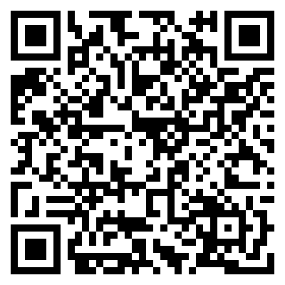
- Collect all publications from July 1, 2022, through February 1, 2023, in chronological order and combine them into one PDF. A minimum of three publications is required. Only PTA newsletters or emails may be entered. See the Judge’s Rubric for content ideas.
- Go to https://form.jotform.com/221745628447059 or scan the QR code. Complete the information and upload the document at the LAPTA Outstanding PTA Newsletter Award Application by February 1, 2023. Information you will need is PTA Name, LUR#, school name and address, contact’s email and phone, editor’s name, and total publications between July 1, 2022, and February 1, 2023. Winners will be announced on March 25, 2023.

