PTA Leader
Toolkit
2023 – 24
Section 11:
Awards, Grants, & Contests

LouisianaPTA.org/awards
LouisianaPTA.org/grants
LouisianaPTA.org/contests

LouisianaPTA.org

INDEX

Awards, Grants, and Contests Summary 168
Monthly Membership Challenges 169
Annual Membership Awards 169
Red Ribbon Drug-Free Poster Contest 170
Reflections Theme Search Contest 171
Reflections Program 172
Outstanding PTA Newsletter Award 173
Advocacy Award for Local PTA Units 174
Advocacy Award for Students 175
Volunteer of the Year Award 176
Mentor-a-PTA Award 177
Apply for National PTA Grants 178
Louisiana PTA Grants 178
Top Grant Writing Tips 178
$750 Literacy Grant Application 179
$750 Healthy Minds Grant Application 180
$500 LAPTA Day of Service Grant Application 181
$500 Creative Teacher Grant Application 182

AWARDS, GRANTS, & CONTESTS SUMMARY
Other Awards:
Volunteer of the Year Award
Outstanding Newsletter Award
Mentor-A-PTA Award

Contests and Reflections:
Red Ribbon Poster Contest
Reflections Theme Contest
Reflections Program with many awards

Grants from LAPTA:
$750 Literacy Grants
$750 Healthy Minds Grants
$500 Day of Service Grants
$500 Creative Teacher Grants

Membership Awards:
August Early Bird Award
September Head Start Award
October Fall Into PTA Award
November Geaux PTA Award
December Lagniappe Award
January Welcome Back Award
February Founders’ Day Award
March Madness Award
Membership Super Grower Award
Membership Marvel Award
Golden Apple Award
Platinum One Voice for Every Child Award
Gold One Voice for Every Child Award
Silver One Voice for Every Child Award

Advocacy Awards:
Outstanding Advocates for Children for a PTA Unit
Outstanding Advocates for Children for a Student
Be the Voice for a PTA Unit
Be the Voice for a Student

LAPTA MONTHLY MEMBERSHIP CHALLENGES

LAPTA has a goal of 13,013 members for our 101st year in 2023-24. LAPTA needs the support of the Local PTA Units to help reach that goal! To be eligible for awards, all PTAs must have Active Affiliation status. The qualifying PTA units will receive recognition and automatically be entered into a monthly drawing for $100!

August Early Bird Award December Lagniappe Award
Submit 25 members by August 31 plus all Officers Achieve 100% of previous year’s membership and
are registered at LouisianaPTA.org/register. completed Active Affiliation Packet by December 31.

September Head Start Award January Welcome Back Award
Jump start the PTA with 50% or more of the previous Keep up the momentum going with 10 new
year’s PTA membership total by September 30. members by January 31.

October Fall Into PTA Award February Founders’ Day Award
Before you trick or treat, submit 31 new memberships In honor of PTA Founders’ Day on February 17, add
by October 31. 17 new members by February 28.

November Geaux PTA Award March Madness Award
File Active Affiliation Report and get more than 75% Make it a sweet sixteen by submitting dues for 16
of previous year’s PTA membership by Nov. 30. new members by March 31.

LAPTA ANNUAL MEMBERSHIP AWARDS

LAPTA has a goal of 13,013 members for our 101st year in 2023-24 and we need our Local PTA Units to help reach that goal! Qualification for awards is done without application. LAPTA uses the information on the Local PTA Unit Membership Reports emailed to submit@LouisianaPTA.org by April 1, 2023. The annual membership awards will be announced at the General Membership Meeting on April 20, 2023. All PTAs who qualify for the Platinum One Voice for Every Child Award enters into a drawing where two PTAs will win $500!

Super Grower Platinum One Voice for Every Child Award
PTA with the greatest increase from previous year. Recruit members equal to 100% of student enrollment;
All winners enter a drawing for two PTAs to win $500!
Membership Marvel Award
Increase membership by 10% over the previous Gold One Voice for Every Child Award
year average or reach your goal from LAPTA. Recruit members equal to 75% of student enrollment.

Golden Apple Award Silver One Voice for Every Child Award
100% membership of teachers and administrators. Recruit members equal to 50% of student enrollment.

KIKI’s RED RIBBON DRUG-FREE POSTER CONTEST

Deadline to submit to LAPTA: October 20, 2023 Submit Entries: form.jotform.com/221746113272146
LAPTA Winners Announced: October 30, 2023 Quantity Offered: 9 (Three/category)
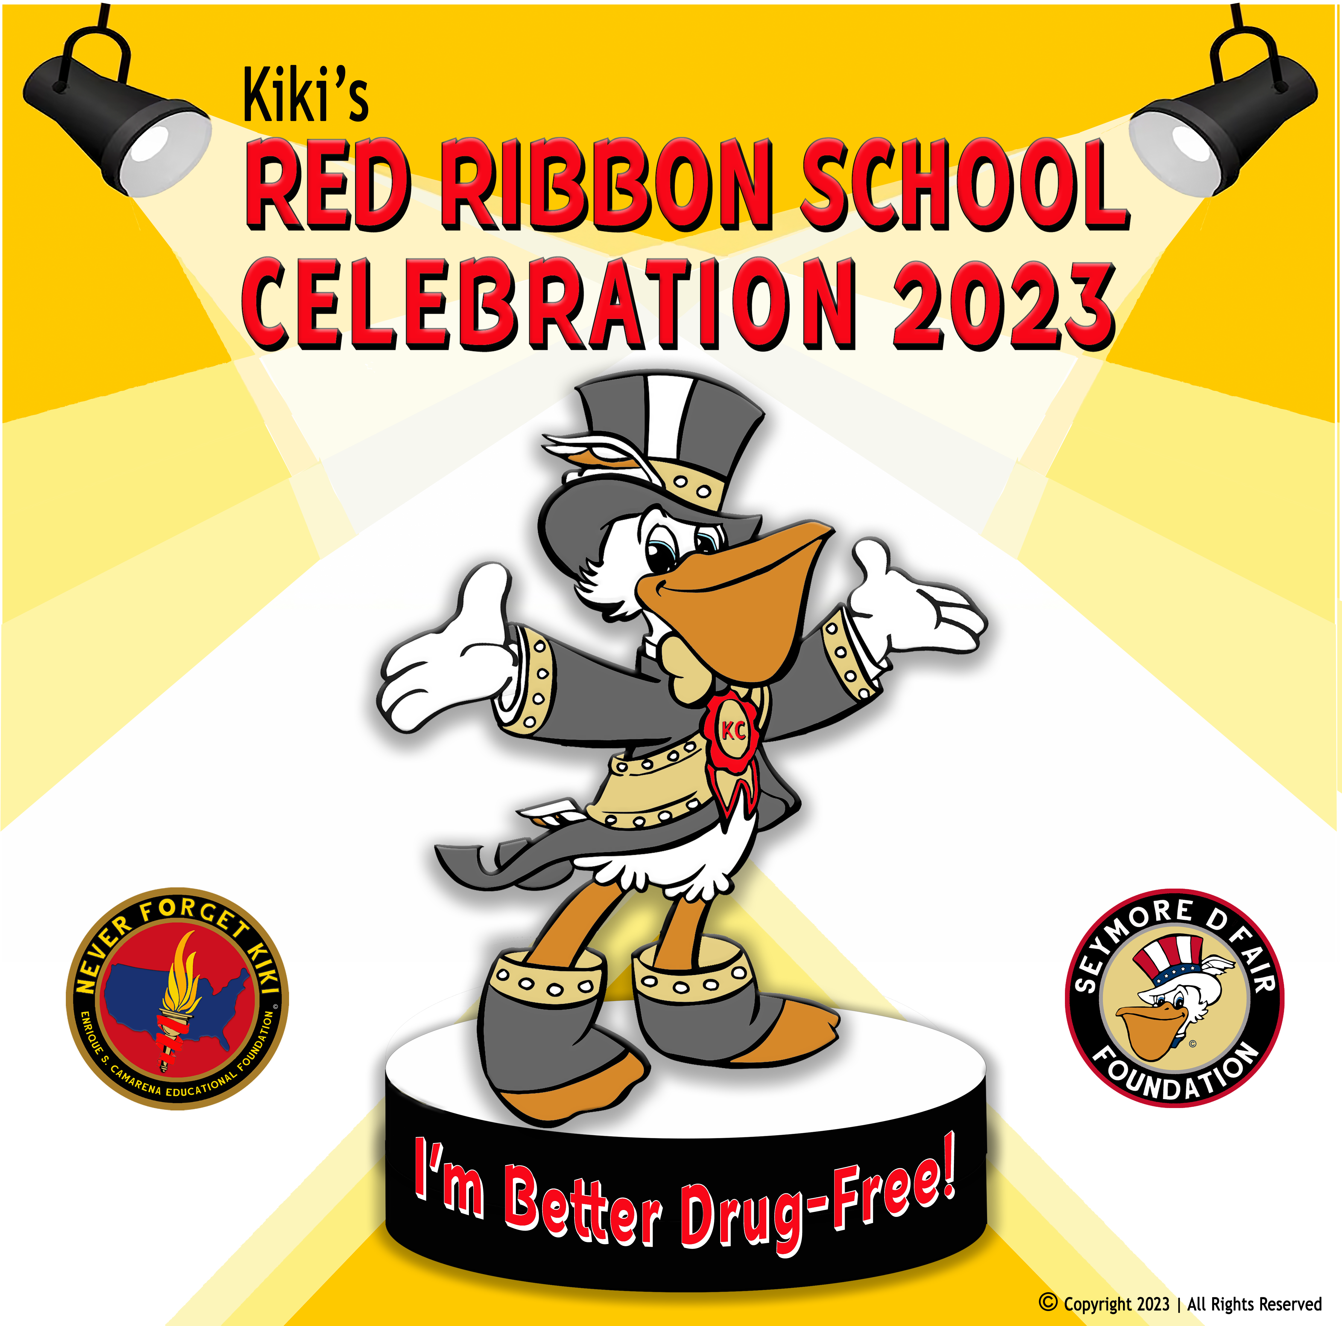
The Louisiana Seymore D’Fair Foundation celebrates their Kiki Red Ribbon Week School Celebration 2023 with the theme “I’m Better Drug-Free.” Enrique "Kiki" Camarena was a Drug Enforcement Administration Agent who was tortured and killed in Mexico in 1985. In honor of Kiki's memory and his battle against illegal drugs, friends and neighbors began to wear red badges of satin. Parents then began to form coalitions using Camarena as their model while embracing his belief that one person can make a difference. Today, the Red Ribbon serves as a catalyst to mobilize communities to educate youth and encourage participation in drug prevention activities. See https://www.youtube.com/watch?v=jSzaUkwumZ0.

Check out SeymoreFoundation.org for support information to implement the program at your school. For this contest students create a drawing on regular 8½ X 11 white paper that illustrates the “I’m Better Drug-Free” theme. Local PTA Units can pick three winners per Grade Category: Primary (Pre-K - Grade 2), Intermediate (Grades 3-6) and Special Artist Category (students of all ages with an ADA Section 504). The deadline to submit posters to LAPTA is October 20, 2023. LAPTA winners will be announced October 30, 2023.

There are several ways this can be organized. The PTA could choose to have the teachers do the contest in their classrooms, an art teacher could organize it, or it could be done at home by the students. Provide copy paper for students or they could even draw on the back of the flyer.

How to Submit Local PTA Winners to LAPTA
- The PTA picks three winners per Grade Category to submit to LAPTA for consideration. Ensure that all winners have signed a Media Release Form with the school. Take a picture of the winning posters in good lighting from directly above the picture. Be careful to include all edges and corners of the drawing in the picture.
- Go to https://form.jotform.com/221746113272146 or scan the QR Code. Complete the form and upload the image by October 20, 2023. Information you will need is PTA name, Grade Category, student name, grade, and parent contact information. Upload images of each winning drawing.

SAMPLE PTA DRUG-FREE POSTER CONTEST FLYER
DEADLINE: Tuesday, October 17, 2023

The Louisiana Seymore D’Fair Foundation celebrates their Kiki Red Ribbon Week School Celebration 2023 with the theme “I’m Better Drug-Free.” Check out SeymoreFoundation.org for more information. Students are to create a drawing that supports the theme on regular 8½ X 11 white paper. What are some ways students can contribute to their community by being drug-free?

[Include how the contest will be organized.] There will be three Awards of Merit winners for each grade and three Awards of Excellence winners [per Grade Category] that will advance to the Louisiana PTA for further judging. The deadline to submit Safety Posters to [details] is [Date], 2023. Winners will be announced Friday, October 20, 2023, and move up to Louisiana PTA for further judging. Louisiana PTA will announce its winners on Monday, October 30, 2023.
2025 – 26 REFLECTIONS THEME SEARCH

Deadline: November 17, 2023 Submit Entries: form.jotform.com/221745830340147
Winners Announced: November 30, 2023

The search is on for a future Reflections theme! National PTA’s Reflections art program has helped students explore their own thoughts, feelings, and ideas, develop artistic literacy, increase confidence, and find a love for learning that will help them become more successful in school and in life. Each year, over 300,000 students in Pre-K through Grade 12 create original works of art in response to a student-selected theme. With this theme, students will create works of art in six categories: Dance Choreography, Film Production, Literature, Music Composition, Photography, and Visual Arts.

Help us pick the theme that will spark fun and creativity for a future National PTA Reflections program! The student who submits the final winning entry for National PTA will receive a $100 prize. We’re looking for the most original theme ideas. This means past themes and duplicate submissions will not be considered. The past list of themes can be found at the bottom of the submission form page linked below.

The Reflections Theme for this year is “I Am Hopeful Because...” by Alice Meko of Hampton Cove Elementary School in Alabama.
To participate, students go to https://form.jotform.com/221745830340147 or scan the QR Code to submit their entry directly with Louisiana PTA. They should check out the past winning themes at the bottom of the entry portal to make sure they do not duplicate past themes.

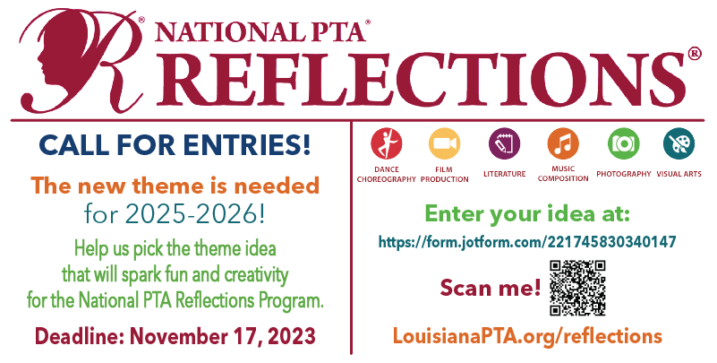
Download this image and share on social media or as a flyer to students!

REFLECTIONS PROGRAM

Winners Due to LAPTA: January 22, 2024 LAPTA Winners Announced: March 1, 2024

National PTA has a long-standing commitment to arts education. The Reflections program provides opportunities for recognition and access to the arts, which boosts student confidence and success in the arts and in life. Each year, over 300,000 students in Pre-K through Grade 12 create original works of art. This 50+ year old program helps them explore their own thoughts, feelings, and ideas, develop artistic literacy, increase confidence, and find a love for learning that will help them become more successful. The Reflections theme is I am Hopeful Because…”

Local PTA Units first register their unit at LouisianaPTA.org/reflections. The PTA unit then chooses which art categories their students will compete in. Students submit their completed works in one or all of the available categories: Dance Choreography, Film Production, Literature, Music Composition, Photography, Visual Arts.

Students must participate in their Grade Category: Primary (Pre-K - Grade 2), Intermediate (Grades 3-5), Middle School (Grades 6-8), High School (Grades 9-12), or Special Artist (students of all ages with an ADA Section 504). Students with the ADA Section 504 may enter in the Special Artist Division or the grade division most closely aligned to their functional abilities.

The Local PTA Unit submits their winners to LAPTA by January 22, 2024. Please set your deadlines earlier to give yourself enough time to pick your winners. All winners are submitted through an online portal. Local Units must be Actively Affiliated with LAPTA by October 27, 2023, for their students to participate.

Reflections Guidelines and Deadlines
- Local PTA Units first pre-register at surveymonkey.com/r/23-24RefRegistration to provide National PTA information on the number of Local PTA Units planning to participate.
- Go to LouisianaPTA.org/reflections for all details, support documentation, and links. The PTA must also register with Louisiana PTA at form.jotform.com/231397127809160 or scan the QR Code.
- The Student Entry Portal link will be shared in the fall. This is the platform LAPTA uses to accept entries.
- Zoom training and written guidance will be provided by LAPTA.
- LAPTA accepts entries in all six Arts Categories. The Local PTA Unit can decide which Arts Categories their students can enter.
- Eligible Local PTA Units can submit three entries from each Arts Category per Grade Category to LAPTA for judging at the state level. If your school has more than one Grade Category, you may submit three entries for each Grade Category. The Grade Categories are Primary (Pre-K to Grade 2), Intermediate (Grades 3-5), Middle School (Grades 6-8), High School (Grades 9-12), and Special Artist (all students with an ADA Section 504).
- ENTRY DEADLINE to LAPTA is January 22, 2024, through the online Student Entry Portal.
- There will be six LAPTA state winners per Grade Category per Arts Category announced on March 1, 2024. We will celebrate our winners in person at the LAPTA Recognition Ceremony n April 20, 2024!
- All information and forms are available at https://LouisianaPTA.org/reflections.
- Questions? Please contact us at arts.education@LouisianaPTA.org.

LAPTA OUTSTANDING PTA NEWSLETTER AWARD

Application Deadline: March 1, 2024 Apply at form.jotform.com/221745628447059
Winners Announced: April 20, 2024 Quantity Offered: 3

Louisiana PTA encourages all units to communicate with their members and community in some form whether it be a printed newsletter, electronic newsletter, or email blast. A newsletter is a great way to exchange news and ideas to bring PTA members closer to each other, to the school, and to all levels of PTA. Communicating information is a vital part of our personal and professional lives, and newsletters play a major role in that process.

Newsletters should be distributed to the entire school population by electronic communication, mail, or sent home with students. PTA membership should never determine if someone receives a newsletter. The name of the communication must identify that it is published by the PTA. The nameplate helps identify the newsletter, communicate its purpose, and invite recipients to read it. Keep the newsletter interesting, accurate, timely, and easy to read. Get an editor who is organized and diligent with excellent writing skills. There is no better way to get a parent to read a newsletter than by including their child's name in it.

Judge’s Rubric (130 Possible Points)
- General Design (25 points possible): Frequency (5 pts); simple, easy to read, clear copy, well-spaced (5 pts); accurate and timely (5 pts); interesting to students and parents (5 pts); attractive layout and space utilized for PTA needs (5 pts)
- Regular Articles (50 points possible): President’s monthly message (10 pts); Principal’s monthly message (5 pts); monthly calendar of events (5 pts); other PTA news like programs, progress or reports of current PTA events and officers (10 pts); school news like messages from Superintendent, School Board members, and counselors, and events such as athletics, clubs, meetings, and assemblies (10 pts); National and Louisiana PTA news (10 pts)
- Special Feature Articles (40 points possible): Classroom or school projects (5 pts); educational workshops for Parents/Students (5 pts); parent education articles (5 pts); special events/workshops (5 pts); student/teacher recognition (5 pts); volunteer recognition (5 pts); State/National PTA Convention (5 pts); news from other advocacy groups and individuals (5 pts)
- Extra Credit (15 points possible): Student photos or drawings (5 pts); table of contents (5 pts); positive features not covered in above areas (5 pts)

To Apply for the Award
- Collect all publications from July 1, 2023, through March 1, 2024, in chronological order and combine them into one PDF. A minimum of three publications is required. Only PTA newsletters or emails may be entered. See the Judge’s Rubric for content ideas.
- Go to https://form.jotform.com/221745628447059 or scan the QR code. Complete the information and upload the document to the LAPTA Outstanding PTA Newsletter Award Application by March 1, 2024. The information needed is PTA Name, LUR#, school name and address, contact’s email and phone, editor’s name, and total publications between July 1, 2023, and March 1, 2024. Winners will be announced on April 20, 2024.

LAPTA ADVOCACY AWARD FOR LOCAL PTA UNITS

Application Deadline: March 1, 2024 Apply at: https://form.jotform.com/221794928286067
Winners Announced: April 20, 2024 Quantity Offered: 2

Local PTAs can apply for the Outstanding Advocates for Children (OAC) or Be the Voice (BTV) advocacy awards. Submit materials and documentation of the completed advocacy work online by March 1, 2024. Winners are announced on April 20, 2024 at the Recognition Ceremony.

Entry information includes Local PTA Name, LUR#, parish, and PTA contact’s name, email, phone, and PTA position. Documentation of the advocacy work is uploaded, as well.

To be eligible for Outstanding Advocates for Children (OAC) Award or the Be the Voice (BTV) Award, Local PTA Units complete some of the Building Awareness Activities and some Civic Engagement Activities. The number of completed activities determines if the PTA is eligible for the 1st Place OAC Award or the 2nd Place BTV Award. The below lists are only suggested activities. There are countless ways a PTA can advocate! Attach information or documentation of each advocacy activity when applying for the award.

Building Awareness Activity suggestions are:
- Educate and communicate LAPTA legislative issues through social media, newsletters, programs, and other avenues to PTA members and the community at large.
- Share advocacy updates and information from LAPTA and how to sign up for the LAPTA newsletter.
- Share LAPTA advocacy alerts to membership.
- Host programs or family events. Pick a legislative priority topic and build a community event around that issue. For example, invite guest speakers, discuss topics, and have a related activity.
- Collaborate with other local PTAs.
- If appropriate, seek community partners and other association relationships to elevate your work.

Civic Engagement Activity suggestions are:
- Write letters or postcards to share your concerns or support regarding LAPTA legislative issues.
- Make phone calls to elected officials in response to LAPTA Legislative Alerts.
- Meet with legislator or legislative staffer to discuss LAPTA legislative priorities. Collaboration with other local PTAs is encouraged.
- Give legislators school tours to meet students, parents, counselors, teachers, and administrative staff. Discuss how PTA legislative issues impact your campus and community.
- Attend an event at the Louisiana State Capital.
- Attend other forums pertaining to public education, child health, and child safety that align with PTA’s goals.

Submit application online at https://form.jotform.com/221794928286067 or scan the QR Code by March 1, 2024. Winners will be announced on April 20, 2024.

LAPTA ADVOCACY AWARD FOR STUDENTS

Application Deadline: March 1, 2024 Apply at: https://form.jotform.com/221794914529163
Winners Announced: April 20, 2024 Quantity Offered: 2

LAPTA accepts applications for the Student Advocacy Award to recognize students who help to truly enhance public education. Students who are involved with civic engagement at an early age are the pillars of Louisiana’s future! The Outstanding Advocates for Children (OAC) Award is the 1st Place award, and the Be the Voice (BTV) Award is 2nd Place award. Submit materials and documentation substantiating the completed advocacy work online.

Entry information includes Local PTA Name, LUR#, parish, student’s contact information, parent’s contact information, and PTA contact’s name, email, phone, and PTA position. Documentation of the advocacy work is uploaded, as well.

Suggestions of Civic Engagement Activities are:
- Sponsored voter registration drive.
- Hosted voter education program.
- Hosted a program or campaign about a LAPTA legislative priority issue.
- Met with legislators representing student’s school community.
- Created an online candidate questionnaire regarding PTA legislative priorities.
- Other community engagement.

Submit application online at https://form.jotform.com/221794914529163 or scan the QR Code by March 1, 2024. Winners will be announced on April 20, 2024.

LAPTA VOLUNTEER OF THE YEAR AWARD

Application Deadline: March 22, 2024 Apply at: https://form.jotform.com/221787194277165
Winner Announced: April 20, 2024 Quantity Offered: 1

The volunteers across the state of Louisiana are truly the heart of the association. Recognize and thank that special person who goes above and beyond for all children, the one who acts as a tireless advocate for children’s education, health, and well-being by honoring them with a Volunteer of the Year Award. This award recognizes one PTA volunteer who made a positive impact on the school and its children. This special person does not need to be the person who logs the most volunteer hours or is a PTA Executive Board member. Letters of recommendation are not required but will be accepted and considered if submitted.

Recognize the very best! Think of the people the PTA might like to honor with a Volunteer of the Year Award, people who care about children and have spent their lives caring about and devoted to the service of children and youth:
  - A PTA leader, past or present
  - The quiet, reliable, unassuming volunteer
  - An outstanding teacher, perhaps one who is retiring this year
  - A senior citizen who serves as a volunteer in the school
  - A school crossing guard who ensures the children get to school safely for years
  - A police officer or juvenile protection worker
  - A legislator who has worked for laws benefiting children

Questions:
1. What makes the accomplishments of this nominee more significant than all other volunteers?
2. Describe the nominee’s innovative or unique approach in performing volunteer service.
3. Describe how the nominee mobilized other volunteers or generated increased resources.
4. Describe the nominee’s ongoing involvement rather than one-time activity.
5. Upload a picture of the nominee and the optional letters of recommendation.

Other needed information is PTA name and LUR#, PTA contact, nominee’s contact information, and a picture of the nominee while volunteering, advocating, or doing PTA work.
Applications must be submitted online at https://form.jotform.com/221787194277165 or scan the QR Code by March 22, 2024. Winners will be announced on April 20, 2024.

MENTOR-A-PTA AWARD

Application Deadline: March 22, 2024 Apply at form.jotform.com/221777772070056
Winners Announced: April 20, 2024 Quantity Offered: 2

LAPTA offers a Mentor-a-PTA Program where a strong, healthy PTA mentors a smaller, protected, or new PTA unit (Mentee) who needs a helping hand. They might share how to implement PTA values and goals through PTA best practices, guidance, and possible financial contributions. As we are all part of Louisiana, the success of one is the success of all. LAPTA encourages our Mentor PTAs to support the other PTAs that are not as strong or are in need. A Mentee PTA might like to sit in on a Board meeting or review agendas, Welcome Packet, membership forms, school flyers, and more.

Be a Mentor or Mentee
If your PTA would like to be paired up with another PTA as either the Mentor or the Mentee, please email Kayla Pagel at President@LouisianaPTA.org. There is no deadline for this.

How can you reach out to others in your community and state? The focus of this program is to mentor through guidance, planning ideas, monthly check-in, and leadership support. Mentors are upbeat, positive advocates who provide tools and direction to the Mentee PTA. If there is a financial contribution, then it must be approved by the General Membership and included in the annual budget. Give the members ownership in the philanthropic work of the PTA. Other non-financial support does not need approval, but always let the membership know the good work done behind the scenes.

Award Application
The Mentor-a-PTA Award recognizes philanthropic work from one PTA to another PTA. To nominate a PTA for the Mentor-a-PTA Award, apply online at https://form.jotform.com/221777772070056 or scan the QR Code. The information needed is the PTA name and city, contact person’s name, phone, and email, and a good description of the philanthropic work done by the nominated PTA.

NATIONAL PTA GRANTS

National PTA offers over 500 grant opportunities annually. Share with LAPTA any grants that the PTA receives so that the accomplishments can be celebrated! If you don’t receive a grant the first time, apply again. Visit PTA.org, go under the Run Your PTA menu, and select Award & Grant opportunities for more information.

LOUISIANA PTA GRANTS

Louisiana PTA financially supports Local PTA Units that work tirelessly to help establish strong family-school partnerships in their community. LAPTA gives up to $12,000 in grants to help engage families, support student success, improve the health and safety of students and families, increase arts education, and more. In addition to evaluating the merits of each application, we may also consider geographic need and other criteria to ensure a robust and diverse pool of grantees. To apply, complete the appropriate application later in this section.

TOP GRANT WRITING TIPS

For many organizations, grant writing is the most important component of their fundraising strategy. When trying to secure funding for a nonprofit, it is important to learn how to write a strong, successful proposal. The best grant proposals are clear, organized documents that illustrate why the PTA should receive funds from the grantor.

First and foremost, know the audience by getting to know the institution offering the grant. Consider its goals, values, and objectives. Understanding these elements helps to demonstrate how and why the PTA is a good fit. Research the eligibility expectations for each specific grantor and meet the minimum requirements. Compile a list of testimonials, recommendations, data sets, and success stories to include with the application. Every grantor is different, but they all want to know their money is being used wisely.
- Know What Grants Exist and When to Apply. Sign up for National PTA’s newsletters at PTA.org/SignUp and bookmark the grants page at PTA.org/Grants.
- Tell a Compelling Story. Make sure all answers work together to highlight the PTA’s strengths and mission or the reason why the PTA exists.
- Share How the Grant Would Impact the School Community. Identify an existing need in the school community and explain how the grant will address that need.
- Show Enthusiasm. Say how the grant will provide an exciting opportunity for the school and PTA.
- Answer All Parts of the Question. Include concrete, detailed examples and explanations that expressly answer the questions asked.
- Promote Family Engagement. Demonstrate how this grant will help to build stronger families in the community and encourage all families to attend the event.
- Get a Second Set of Eyes. Ask someone to proofread the proposal for spelling, grammar, and clarity before submitting the application.

Peek, Sean. “How to Write a Grant Application for Your Organization.” USChamber.com, February 5, 2021.

$750 LAPTA LITERACY GRANT APPLICATION

Application Deadline: November 17, 2023 Apply at form.jotform.com/221748002230038
Winners Announced: December 1, 2023 Quantity Offered: 4 (One/category)

The LAPTA $750 Literacy Grant 750 helps Local PTA Units host literacy programs or purchase literary items for the school library or a teacher’s classroom library. Literacy skills in Louisiana are unacceptably low, and LAPTA and National PTA are making literacy opportunities a priority for our children. For program suggestions, see PTA.org/home/programs/family-reading. One grant will be awarded per Grade Category: Primary (Pre-K - Grade 2), Intermediate (Grades 3-5), Middle School (Grades 6-8), High School (Grades 9-12). The following information is what is needed to apply.

Entry information includes Local PTA Name, LUR#, parish, mailing address, the Grade Category, and PTA contact’s name, email, phone, and PTA position.

Requirements
- All grant funds must support age-appropriate programs for literacy skills.
- The program ideally should serve a majority of the school population.
- The funds will be used by May 24, 2024.
- Documentation of the spent funds must be emailed to submit@LouisianaPTA.org by May 24, 2024.

Questions
- Describe how the PTA plans to spend the funds to increase literacy for their students. Include the purchased items, goals, supplies, volunteers needed, and any other details.
- What are the top three literacy challenges for the children in the community?
- If the school has a library, what is the name of the school librarian?
- How will the program be publicized to parents, families, and the community before and after the event?

The above PTA fully understands that if it receives this grant, the money shall not be used for other programs or activities except for those listed on this application form. A written evaluation of the efforts is due to submit@LouisianaPTA.org by May 24, 2024, unless an extension has been granted by the LAPTA President. The evaluation must contain all details pertaining to the use of the funds received under this grant including receipts of expenditures and any other supporting documentation. Failure to provide documentation requested as it pertains to this application may result in forfeiture of any or all grant funds and ineligibility for future grants.
Applications must be submitted online at https://form.jotform.com/221748002230038 or scan the QR Code.

$750 LAPTA HEALTHY MINDS GRANT APPLICATION

Application Deadline: March 27, 2024 Apply at form.jotform.com/221748198534162
Winners Announced: May 1, 2024 Quantity Offered: 4 (One/category)

The LAPTA Healthy Minds Grants encourage Local PTA Units to host mental health activities, events, or programs at their supported schools. It is important to support the mental health of all children before, during and after challenges arise and to support parents' and caregivers' mental health, too! National PTA developed the PTA Healthy Minds Program to empower families to make mental health an everyday priority.

National PTA has a new Mental Health Pilot Program and Louisiana was one of only a few to implement it! Jessica Latin was named as the Louisiana Healthy Minds State Champion. She is a licensed professional counselor and serves as the secretary for the Judson Warriors PTA in Shreveport, LA. Throughout the next few years, she will be empowering families with resources and tools to help them make mental health a daily priority! Follow her and learn more at PTA.org/HealthyMinds, search “Louisiana PTA Healthy Minds” on Facebook, or email Jessica at healthyminds@LouisianaPTA.org.

One grant will be awarded per Grade Category: Primary (Pre-K - Grade 2), Intermediate (Grades 3-5), Middle School (Grades 6-8), High School (Grades 9-12).

Entry information includes Local PTA Name, LUR#, parish, mailing address, the Grade Category, and PTA contact’s name, email, phone, and PTA position.

Requirements
- All grant funds must support an age-appropriate mental health activity, event, or program.
- The program should ideally serve a majority of the school population.
- The program will occur by December 31, 2024.
- Documentation of the implemented program must be emailed to submit@LouisianaPTA.org by May 24, 2024.

Questions
- What is the name of the school counselor or Mental Health Provider?
- What are the top three challenges for the MHP?
- Describe the mental health program, event, or activity the PTA wants to host for their students. Include the goals, supplies, volunteers needed, and any other details.
- What are the top three mental health challenges for children in the community?
- How will the program be publicized to parents, families, and the community before and after the event?

The above PTA fully understands that if it receives this grant, the money shall not be used for other programs or activities except for those listed on this application form. A written evaluation of the efforts is due to submit@LouisianaPTA.org by December 31, 2024, unless an extension has been granted by the LAPTA President. The evaluation must contain all details pertaining to the use of the funds received under this grant including receipts of expenditures and any other supporting documentation. Failure to provide documentation requested as it pertains to this application may result in forfeiture of any or all grant funds and ineligibility of future grants.
Applications must be submitted online at https://form.jotform.com/221748198534162 or scan the QR Code.

$500 LAPTA DAY OF SERVICE GRANT APPLICATION

Application Deadline: March 1, 2024 Apply at form.jotform.com/221748846538166
Winners Announced: April 20, 2024 Quantity Offered: 4 (One/category)

The four LAPTA Day of Service Grants encourage Local PTA Units to reach beyond the school and into the community to make a difference. Where is there a need? Who needs the PTA? February 17 is the National PTA Founders’ Day. How can you continue the rich legacy of National PTA? Perhaps you could partner with other aligned non-profits or agencies who serve populations like foster kids, food insecurity programs, the elderly, a community library, or an animal shelter. One grant will be awarded per Grade Category: Primary (Pre-K - Grade 2), Intermediate (Grades 3-5), Middle School (Grades 6-8), High School (Grades 9-12). The following information is what is needed to apply online.

Entry information includes Local PTA Name, LUR#, parish, mailing address, the Grade Category, and PTA contact’s name, email, phone, and PTA position. Documentation of the advocacy work is uploaded, as well.

Requirements
- All grant funds must support a community outreach program.
- The school families must support the program.
- The program will occur by December 31, 2024.
- Documentation of the implemented program must be emailed to submit@LouisianaPTA.org by December 31, 2024.

Questions
- What are the top three community goals for the school’s administration?
- Describe the community outreach or day of service program the PTA wants to host. Include the location, goals of the event(s), supplies, volunteers needed, and any other details.
- What are the top three challenges for the group, nonprofit, or agency that you are trying to support?
- How will the program be publicized to parents, families, and the community before and after the event?

The above PTA fully understands that if it receives this grant, the money shall not be used for other programs or activities except for those listed on this application form. A written evaluation of the efforts is due to submit@LouisianaPTA.org by December 31, 2024, unless an extension has been granted by the LAPTA President. The evaluation must contain all details pertaining to the use of the funds received under this grant including receipts of expenditures and any other supporting documentation. Failure to provide documentation requested as it pertains to this application may result in forfeiture of any or all grant funds and ineligibility of future grants.
Applications must be submitted online at https://form.jotform.com/232048704031142 or scan the QR Code.

$500 LAPTA CREATIVE TEACHER GRANT APPLICATION

Application Deadline: April 1, 2024 Apply at form.jotform.com/221796420623152
Winners Announced: April 20, 2024 Quantity Offered: 2

LAPTA offers Creative Teacher Grants to classroom teachers to fund creative, innovative, and fun programs or projects for students. Grants may fund instructional and classroom materials, videos, parent involvement programs, or any activity or material which supports student enjoyment, wonder, and engagement. The hope is that this grant will result in fun and enriching projects or opportunities for the students that would not otherwise have been possible.

The proposal shall be clear and logical and include a specific objective; a creative or innovative approach; clear description of instructional procedures, methods, or treatments; and emphasis on student enjoyment, wonder, and excitement. The teacher or group of teachers must be current PTA members at their school. Funds must be used by December 31, 2024.

The information needed for the online application is contact information, applicants who are current PTA members at their school, and name of proposed project, including:
- What will the project accomplish?
- Which and how many students will the project serve?
- How will the project specifically benefit the students?
- What is fun, creative, and innovative about the project?
- What are the complete details of the project?
- How will the project be publicized to parents, families, and the community before and after the project?
- Further support documentation or video uploads may be included to improve the application.

The applicant fully understands that if it receives this grant, the money shall not be used for other programs or activities except for those listed on this application form. A written evaluation of the efforts is due to submit@LouisianaPTA.org by December 31, 2024, unless an extension has been granted by the LAPTA President. The evaluation must contain all details pertaining to the use of the funds received under this grant including receipts of expenditures and any other supporting documentation. Failure to provide documentation requested as it pertains to this application may result in forfeiture of any or all grant funds and ineligibility of future grants.
Applications must be submitted online at https://form.jotform.com/221796420623152 or scan the QR Code.

