MJH PTA BOP’S FROZEN CUSTARD & SMOOTHIE KING DAYS

Smoothie King on October 31, 2019

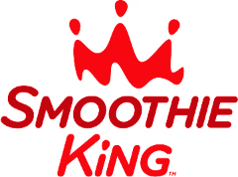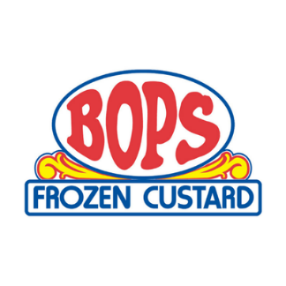

**DEADLINE is Tuesday, October 29** for Bops Frozen Custard on September 5.

MJH PTA has 7 shake days during the year with Smoothie King and Bop’s Frozen Custard. To make it MUCH easier on everyone, parents may now **pre-pay for the year or just for the days you choose!** Please take advantage of this if you can, although forms will still go out during the year for each day. The smoothies and shakes are $3 with the MJH PTA receiving 50% of the sales to support our student and teacher programs.

***If you already submitted an order, the 1st hour teachers will receive that list by August 30. MJH PTA is also sending home a confirmation of that order to each student.

Student Name Grade 1st Hour Teacher 7th Hour Teacher

Parent Name Cell Phone Email

|  |  |  |  |  |  |  |  |
| --- | --- | --- | --- | --- | --- | --- | --- |
| Choose the flavors for the days you would like to purchase a shake in the chart below.   * For **Smoothie King**, all shakes are dairy-free and gluten-free. Strawberry XTreme is plain strawberry, and Angel Food is strawberry and banana. * For **Bop’s Frozen Custard**, all shakes are gluten-free. You can choose the DF dairy-free option which is strawberry. | | | | | | | |
| **Date** | **Company** | **Check your flavor choice.** | | | | | **Price for 1** |
| Thu, September 5, 2019 | Bop’s Frozen Custard | * Vanilla | * Chocolate | | * DF | | $3 |
| Thu, October 31, 2019 | Smoothie King | * Strawberry Xtreme | | * Angel Food | | | $3 |
| Fri, December 13, 2019 | Bop’s Frozen Custard | * Vanilla | * Chocolate | | * DF | | $3 |
| Fri, January 24, 2020 | Bop’s Frozen Custard | * Vanilla | * Chocolate | | * DF | | $3 |
| Thu, February 20, 2020 | Smoothie King | * Strawberry Xtreme | | * Angel Food | | | $3 |
| Fri, March 27, 2020 | Bop’s Frozen Custard | * Vanilla | * Chocolate | | * DF | | $3 |
| Thu, April 30, 2020 | Smoothie King | * Strawberry Xtreme | | * Angel Food | | | $3 |
| *(Payment for this and other PTA items may be combined.)* Total # of Shakes: X $3 = Total Price: | | | | | | **$ .** | |

Payment may be cash, check to MJH PTA, or credit card *(+3.25% bank fee)*. PTA will call you for credit card payment.

*All payments to the MJH PTA are tax-deductible.* **Questions?** Contact Beth Maillho at (985) 778-5799 or mjh.ptapres@gmail.com, or Monica Givens at (985) 773-4860 or mjh.ptashakes@gmail.com

Students can return this order form with payment through their 1st hour or 7th hour teachers.

Orders may be placed at any time throughout the year.

**DEADLINE is Tuesday, September 3** for Bops Frozen Custard on September 5.