PTA Leader
Toolkit
2023 – 24
Section 10:
Bylaws, Standing Rules, & Articles of Incorporation

LouisianaPTA.org/bylaws

LouisianaPTA.org

INDEX

Articles of Incorporation 162
Bylaws & Amendments: Updating & Approval 163
Bylaws Approval Timeline Summary 164
Bylaws & Amendments Approval Form 165
Instructions for Bylaws Template 166
Standing Rules 167

ARTICLES OF INCORPORATION
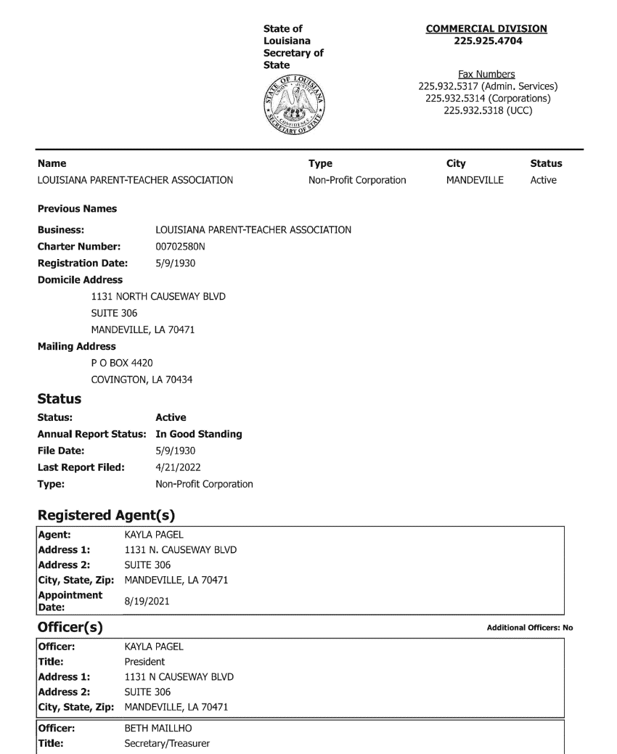
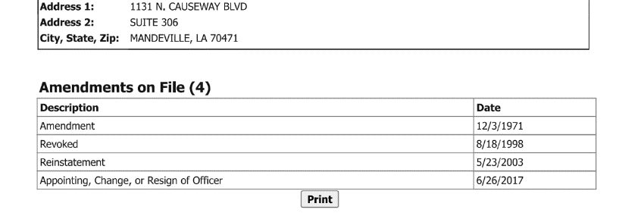
SAMPLE
Louisiana law requires that all non-profits register with the Louisiana Secretary of State’s office. There is a $75 initial fee to file Articles of Incorporation with the Louisiana Secretary of State at geauxbiz.com.

The PTA must file the Annual Report updating its officers yearly. Visit Louisiana Secretary of State website at geauxbiz.com to renew, set up annual email reminders, update the officers, and pay a $15 renewal fee. The Articles of Incorporation shall be kept permanently on file and are part of the annual Active Affiliation Report that is submitted to LAPTA. See LouisianaPTA.org/activeaffiliation.

After logging into geauxbiz.com under “Quick Links,” select “File Annual Report.” Or click “Get Started” button. Select “File an amendment, such as an annual report, with the Louisiana Secretary of State.” Follow the steps to update officer data.

APPROVAL OF BYLAWS AND AMENDMENTS

Bylaws are the fundamental governing rules of a PTA. They contain the basic rules related to conducting the unit’s business and governing its affairs. The Bylaws define the primary characteristics of the organization, prescribe how the association functions, and include all rules considered important to the rights and responsibilities of membership.

The Bylaws are a template created by LAPTA that includes required language which cannot be changed by the local PTA. The customizable areas are changeable by the local PTA to best meet their needs. Download the Bylaws template at LouisianaPTA.org/bylaws. Amendments to the customizable areas may occur at any time. They require approval by the General Membership at a meeting with thirty days (30) notice and a final approval by LAPTA.

LAPTA requires all local units to submit updated Bylaws every three years. All approved, official Bylaws have an “LAPTA Approval Date” on page one. The Board needs to know when the Bylaws expire and timely update the Bylaws. To update or amend the Bylaws:

Form a Bylaws Committee of at least three members which must be approved by the General Membership by making a motion. The committee shall include experienced and knowledgeable PTA members. The President should have a copy of the current approved Bylaws or request a copy from LAPTA at Bylaws@LouisianaPTA.org.

Notify the General Membership in writing at least 30 days prior to the meeting where the vote will occur to amend or update the Bylaws.

Obtain the official fill-in-the-blank LAPTA Bylaws template online at LouisianaPTA.org/bylaws or email Bylaws@LouisianaPTA.org.

Provide the Bylaws Committee with the old Bylaws for reference. Consider recommendations submitted by the Board of Directors and General Membership. For proposed amendments, all changes must meet the needs of the unit, have clear intent, and not conflict with the Louisiana and National PTA Bylaws. Amendments need to reference their article heading, section number, and line number(s) in the Bylaws.

Present the General Membership with the proposed Bylaws or amendments before voting. Approval requires a two-thirds vote of the members present.

Complete the Bylaws and Amendments Approval Form found at the end of this section or at LouisianaPTA.org/bylaws. Email the approved Bylaws or amendment with the Approval Form to Bylaws@LouisianaPTA.org. If an amendment does not fit in the space on the form, check the box for an attached addendum.

Give LAPTA 30 days to review and approve the Bylaws or amendments. If there are questions, LAPTA will contact the President. Once approved, they will be stamped “APPROVED,” signed, and dated. The stamped, signed, and dated copy is the official copy of the Bylaws and are current for three years. The Bylaws and amendments become effective once LAPTA emails back the final approval to the President’s email. Save the digital file in the PTA records and share with the Board.

BYLAWS APPROVAL TIMELINE SUMMARY

The following outlines the deadlines and steps to properly update the Bylaws based on standard parliamentary procedure. Refer to LouisianaPTA.org/bylaws for further guidance. The Bylaws need to be formatted in the Louisiana Local Unit Bylaws, May 2022 Bylaws template style.

- Pick the date for the General Membership meeting that will vote on the Bylaws, noting that two General Membership meetings are needed to complete the process.
- At the first General Membership meeting, appoint the Bylaws Committee of at least three people by making a motion.
- The Bylaws Committee meets to complete the proposed LAPTA Bylaws template.
- At least thirty days before the second General Membership meeting, publicly give notice of the meeting and post the Bylaws for review by the membership.
- At the second General Membership meeting, ensure that the quorum is met. Present the Bylaws. Have time for any questions or changes. Make a motion to accept the Bylaws. A two-thirds vote of approval by the members present is required. Complete the Bylaws Approval Form.
- Email the Bylaws Approval Form and the Bylaws to LAPTA at Bylaws@LouisianaPTA.org. LAPTA will review the Bylaws, give them the final stamp of approval and date of acceptance, and then email the stamped copy back to the PTA.

Here is a sample timeline if the Bylaws were to be presented and approved at a General Membership meeting held on December 15.

August 28: The first General Membership Meeting appoints the Bylaws Committee by making a motion.
September - November: Bylaws Committee meets as needed to complete the Bylaws template found at LouisianaPTA.org/bylaws. The committee can email the proposed Bylaws to LAPTA for review at Bylaws@LouisianaPTA.org.
November 10: Publicize the date for the December 15 General Membership meeting and post the proposed Bylaws for review by the membership.
December 15: At the General Membership meeting with a quorum present, review the proposed Bylaws and allow for questions or discussions. Make a motion to accept the Bylaws. A two-thirds vote is required. Complete the Bylaws Approval Form.
December 16: Email the approved Bylaws and the Bylaws Approval Form to Bylaws@LouisianaPTA.org.
January 5: LAPTA reviews the Bylaws, stamps and dates them, and emails the final approved Bylaws to the PTA.

Enter your dates here:

Date of 1st General Membership Meeting when Bylaws Committee is formed.

Dates when the Bylaws Committee will meet to complete the LAPTA Bylaws Template.

Date 30+ days before the 2nd General Membership meeting when the meeting date is publicized and the Bylaws are posted for review by the membership.

Date of 2nd General Membership meeting when the Bylaws are presented and voted on.

Date Bylaws and the Bylaws Approval Form are emailed to LAPTA at Bylaws@LouisianaPTA.org.

Date 30 days after emailing LAPTA which is the deadline for LAPTA to email the final approved Bylaws back to the PTA.

BYLAWS AND AMENDMENTS APPROVAL FORM

Local PTA units are required to update and submit their Bylaws to LAPTA every three years. The Bylaws Approval Form and the LAPTA Bylaws template are required. Visit LouisianaPTA.org/bylaws for details. Bylaws not in compliance will be returned to the PTA. Email the completed Bylaws Approval Form and LAPTA Bylaws template or the amendments to Bylaws@LouisianaPTA.org. Please allow 30 days for LAPTA to approve the Bylaws or amendments. Once completed, LAPTA will email the approved Bylaws or amendments to the President’s email.

Local PTA Unit Name Parish LUR#

President’s Email President’s Phone

The Bylaws or Amendments were approved at the General Membership meeting held on .
DATE

Choose one.
The Local PTA Unit is: an Existing PTA a Reinstated PTA a New PTA

Choose all that apply.
The Bylaws approved by the General Membership are attached.

The approved amendments are listed below with the article heading, section number, and line number(s).

If more space is needed for amendments, check here for the attached addendum.

President’s Signature Date Secretary’s Signature Date

President’s Name Secretary’s Name

Email the completed Bylaws Approval Form and Bylaws template (if applicable) to Bylaws@LouisianaPTA.org.

Contact Bylaws@LouisianaPTA.org with any questions.

INSTRUCTIONS FOR BYLAWS TEMPLATE

LAPTA fill-in-the-blank Bylaws template simplifies the process and expedites approval. Text not in bold is required and cannot be altered. Changes can only be made to sections of the Bylaws that have bolded areas. Additional changes to these sections must be listed in an addendum and comply with LAPTA rules.

Page 11: Article X: Committees, Section 5. Nominating Committee
Line 453: Write the number of members for the Nominating Committee (no less than three and an odd number).
Line 458: Write the month/months the Nominating Committee reports to the General Membership meeting in which elections will be held.

Page 12: Article XI: General Membership Meetings
Line 473: Section 1. Meeting Dates. Write the months the unit will hold General Membership meetings. Be sure to include the month/months the election is held.
Line 480. Section 3. Quorum. Write a quorum of at least twice the number of officers listed in Article VI: Officers and Their Elections, Section 3 and any additional officers listed by the unit in the addendum, plus one. This prevents the perception that officers could conduct PTA business by themselves.
Line 482. Elections Meeting. Fill in the month/months the elections will be held which must be when the General Membership meeting is held.

Page 13: Addendum. List any additional changes to the Bylaws. The page number plus article and section number are required when listing the changes. An example:
Page 12, Article XI, Section 4. Elections meeting. Current wording: The annual elections meeting shall be held in the month of April.
The proposed change will be to: The annual elections meeting shall be held in the month of May.

Questions? Email bylaws@LouisianaPTA.org.

Page 1: PTA Unit Information
Line 2: PTA Unit’s Name
Line 4: Local Unit Registration Number (LUR#)
Line 5: Federal Employer Identification Number (EIN)
Line 7: School that the PTA supports
Lines 9 -11: School address
Line 13: Parish that the PTA Unit is in

Page 2: Article I: Name
Line 35: PTA Unit name and city

Page 6: Article V: Membership and Dues
Line 214: Fill in the dues amount for each membership type with the number of memberships allowed. For example, $8 for a single, $5/student, $15/couple (2 members), $50/corporate (5 memberships).

Page 6: Article VI: Officers and Their Election
Line 228: Write the number of vice-president(s)
Line 229: Write the number of secretary(ies)
Line 231: Write any additional officers in the addendum.
Line 234: Write the month/months elections will be held; must be when a General Membership Meeting is held.
Line 243: Write the date the elected officers will assume their positions, usually July 1 – June 30.
Line 244: Write the length of the elected officer’s terms.
Line 245: Write the maximum number of additional terms elected officers are allowed to serve.

Page 9: Article VIII: Executive Committee, Section 4B. Meetings
Line 362: Write the number of days’ notice provided for a special meeting of the committee.

Page 10: Article IX: Board of Directors, Section 5B. Meetings
Line 409: Write the number of days’ notice provided for a special meeting of the board.

STANDING RULES

Standing Rules are detailed guidelines that contain additional information on who does what within the PTA. They set forth the procedures adopted to direct the PTA and to accomplish specific PTA work. They provide continuity and serve as a guide to ensure the orderly transfer of duties from one administration to the next. They are a valuable training tool for the orientation of new board members and may contain any traditions or specific information that pertains to the PTA.

Local PTA Units should have their own personal Standing Rules. Standing Rules are the rules the PTA adopts to administer PTA work under the provisions of the Bylaws. Standing Rules must conform to and may not conflict with the Bylaws. They are generally not adopted when a PTA is newly organized but are developed and adopted as needs arise. The following guidelines are suggestions and should be attached to the Standing Rules for ongoing reference and instruction.

Standing Rules are more flexible than Bylaws. They do not contain parliamentary procedure and are adopted and amended. Standing Rules are kept with the Bylaws in the officers’ procedure binders and are passed on to incoming officers. All Board members and committee chairs should have a copy of the Standing Rules. The Bylaws and Standing Rules need to be studied by incoming officers and reviewed frequently for understanding and training to ensure they are still accurate and applicable. The secretary has a copy of the Standing Rules available at all PTA meetings.

Each set of Standing Rules is unique. No two are alike because no two PTAs are alike. Developing Standing Rules is not difficult. They may be adopted individually in a General Membership meeting as the need arises.

To adopt a set of Standing Rules, appoint a committee of at least three experienced, knowledgeable members of the PTA to prepare them. Using the Bylaws as a starting point, the committee should consider each provision and then formulate instructions for applying it. Use the minutes of Board and General Membership meetings and the experience of committee members as additional resources. After the committee prepares the Standing Rules, they are presented to the Board for review and then to the General Membership for approval by a majority vote.

Standing Rules may contain as much information and detail as needed for the functioning of the PTA. The more details included, the easier the job will be for future board members. Standing Rules should include any specific, detailed duties and responsibilities for individual officers, Executive Committee, Board, and committee chairs. Details and descriptions that would be helpful include any consistent person, date, location, time, event, activity, assignment, tradition, and process that occurs traditionally during the PTA year.

See a sample Standing Rules at LouisianaPTA.org/bylaws. Detailed information about the following additional topics and more could be included in the Standing Rules:
- Needs assessment
- Student involvement
- Fiscal policies and procedures, including location of bank and updating signatories and debit cards
- Nominating Committee instructions
- Installation of new officers
- Requirements for special recognitions and awards
- Equipment the PTA owns and where it is located
- LAPTA meetings and who attends
- Titles and specific duties of the Vice-Presidents
- Orientation of new Board Members
- Procedure binders
- Meetings
- Details for standing and special committees, which might include finance, membership, public relations, newsletter, volunteers, programs, legislation, Reflections, budget, teacher appreciation, hospitality, etc.
- Committee’s duties, who serves on them, and how committee members are determine

