Students, participate in the fun Reflections Arts Contest! Entries can be in Dance Choreography, Film Production, Literature, Music Composition, Photography, or Visual Arts. Students enter the contest in their grade division or the Accessible Arts Division for students with ADA Section 504 accommodations. Before you begin, read the complete guidelines and rules at LouisianaPTA.org/students.

Create your entries around the annual theme of “I Belong!”
Deadline is ...........

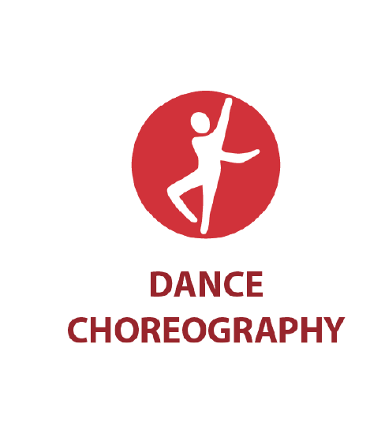









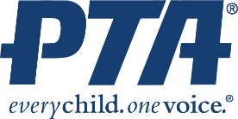

Deadline for Entries: PTA Contact for Details & Guidelines:
Details
DATE

